
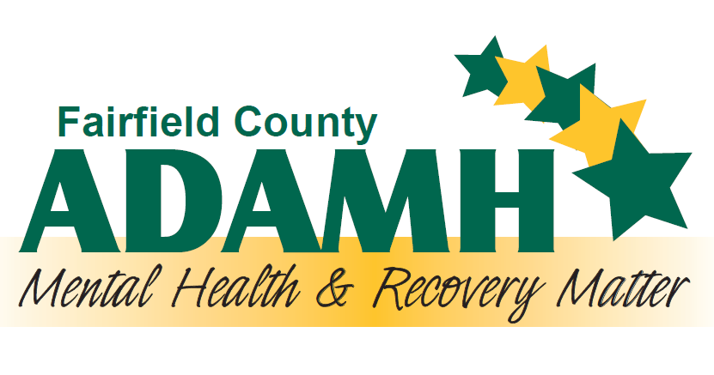
TEAM LEAD OR DEPARTMENT MANAGER
Communication, supervision and training, monitor utilization of service and staff productivity, report writing, facilitate team meetings, organization
Minimum of master’s degree with LCDC, LCDC II, LCDC III, LICDC, LPC, LSW, LPCC, LPCC-S, LISW, or LISW-S
SUD COUNSELOR
Advocacy, assessment, rapport-building, treatment planning, organization, active listening skills, maintain direct service productivity
Minimum of bachelor’s degree with LCDC, LCDC II, LCDC III, LICDC, LPC, LSW, LPCC, or LISW
for Substance Use Disorder Treatment
Professionals in Fairfield County
CLINIC MANAGER OR SITE SUPERVISOR
Monitor and develop programming, budget, policies and procedures. Oversee operations of clinic and builds community relationships
Minimum of master’s degree with LCDC, LCDC II, LCDC III, LICDC, LPC, LSW, LPCC, LPCC-S, LISW, or LISW-S

PEER RECOVERY SUPPORTER
Advocacy, outreach, coordination and linkage, rapport-building, lived experience
Ohio PRS Certificate

SUD CASE MANAGER
Advocacy, assessment, outreach, rapport-building, treatment planning, organization, linkage and referral, maintain direct service productivity
Minimum of high school diploma with a CDCA certificate

